Shebang Line

The first line of all your Python programs should be a *shebang* line, which tells your computer that you want Python to execute this program. The shebang line begins with #!, but the rest depends on your operating system.On Windows, the shebang line is #! python3.

Running Python Programs on Windows

On Windows, the Python 3.4 interpreter is located at C:\Python34\python.exe. Alternatively, the convenient py.exe program will read the shebang line at the top of the .py file’s source code and run the appropriate version of Python for that script. The py.exe program will make sure to run the Python program with the correct version of Python if multiple versions are installed on your computer.

To make it convenient to run your Python program, create a .bat batch file for running the Python program with py.exe. To make a batch file, make a new text file containing a single line like the following:

@py.exe C:\path\to\your\pythonScript.py %*

Replace this path with the absolute path to your own program, and save this file with a .bat file extension (for example, pythonScript.bat). This batch file will keep you from having to type the full absolute path for the Python program every time you want to run it. I recommend you place all your batch and .py files in a single folder, such as C:\MyPythonScripts or C:\Users\YourName\PythonScripts.

The C:\MyPythonScripts folder should be added to the system path on Windows so that you can run the batch files in it from the Run dialog. To do this, modify the PATH environment variable. Click the **Start** button and type **Edit environment variables for your account**. This option should auto-complete after you’ve begun to type it. The Environment Variables window that appears will look like [Figure B-1](https://automatetheboringstuff.com/appendixb/#calibre_link-1900).

From System variables, select the Path variable and click **Edit**. In the Value text field, append a semicolon, type **C:\MyPythonScripts**, and then click **OK**. Now you can run any Python script in the C:\MyPythonScripts folder by simply pressing WIN-R and entering the script’s name. Running pythonScript, for instance, will run pythonScript.bat, which in turn will save you from having to run the whole command py.exe C:\ MyPythonScripts\pythonScript.py from the Run dialog.

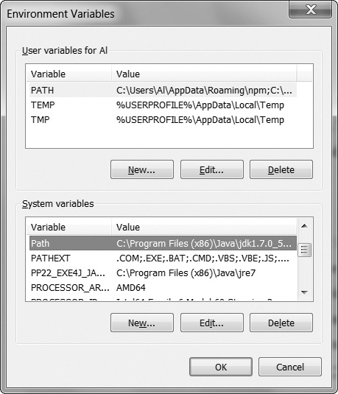

Figure B-1. The Environment Variables window on Windows

To run your Python programs, save your .py file to your home folder. Then, change the .py file’s permissions to make it executable by running chmod +x pythonScript.py. File permissions are beyond the scope of this book, but you will need to run this command on your Python file if you want to run the program from the Terminal window. Once you do so, you will be able to run your script whenever you want by opening a Terminal window and entering ./pythonScript.py. The shebang line at the top of the script will tell the operating system where to locate the Python interpreter.